Homeless Management Information System

Problem Statement

The greater problem faced by the society today is the need to keep a track of the homeless. It is extremely crucial for them to be served, as they are also a part of the community. And keeping a track of the homeless is extremely difficult as their data can often be scattered. manual data collection effort is limited and might result to flawed decision making. Thus, it is import ant to maintain a single record for each existing homeless, along with the initiatives taken to rescue them for maintaining their track record.

Solution

The proposed system is designed to capture information over time on the characteristics and service needs of all men, women and children experiencing homelessness. Its primary purpose is to accurately identify the scope of the problem and the effectiveness of the efforts to ameliorate the problem of an individual homeless. It provides the opportunity to improve access to in delivery of services for people experiencing homelessness.

Functionalities

**NGO**

1. NGO Organization

* Add a homeless member
* View Status of added homeless member
* Supply with essentials
* Update homeless member
* Get record from government body to supply essential
* Get criminal record from police

**Government Body**

1. Police Body

* Add homeless member
* Check criminal records and send approval to NGO and hospital
* View and update homeless person details
* Verify homeless person details
* Track each homeless person record

1. Census Bureau

* Check if homeless is below poverty line
* Send request to NGO for supplies
* Send request to Hospital for treatment

**Hospital**

1. Doctor

* View/Update only medical history/record of homeless person
* View medical history of the homeless
* Suggest a treatment Plan

1. Lab Assistant

* Get record from government body for medical
* Get criminal record from police
* Check doctor’s treatment and supply medical
* Perform tests and update medical History

Ecosystem Architecture Diagram

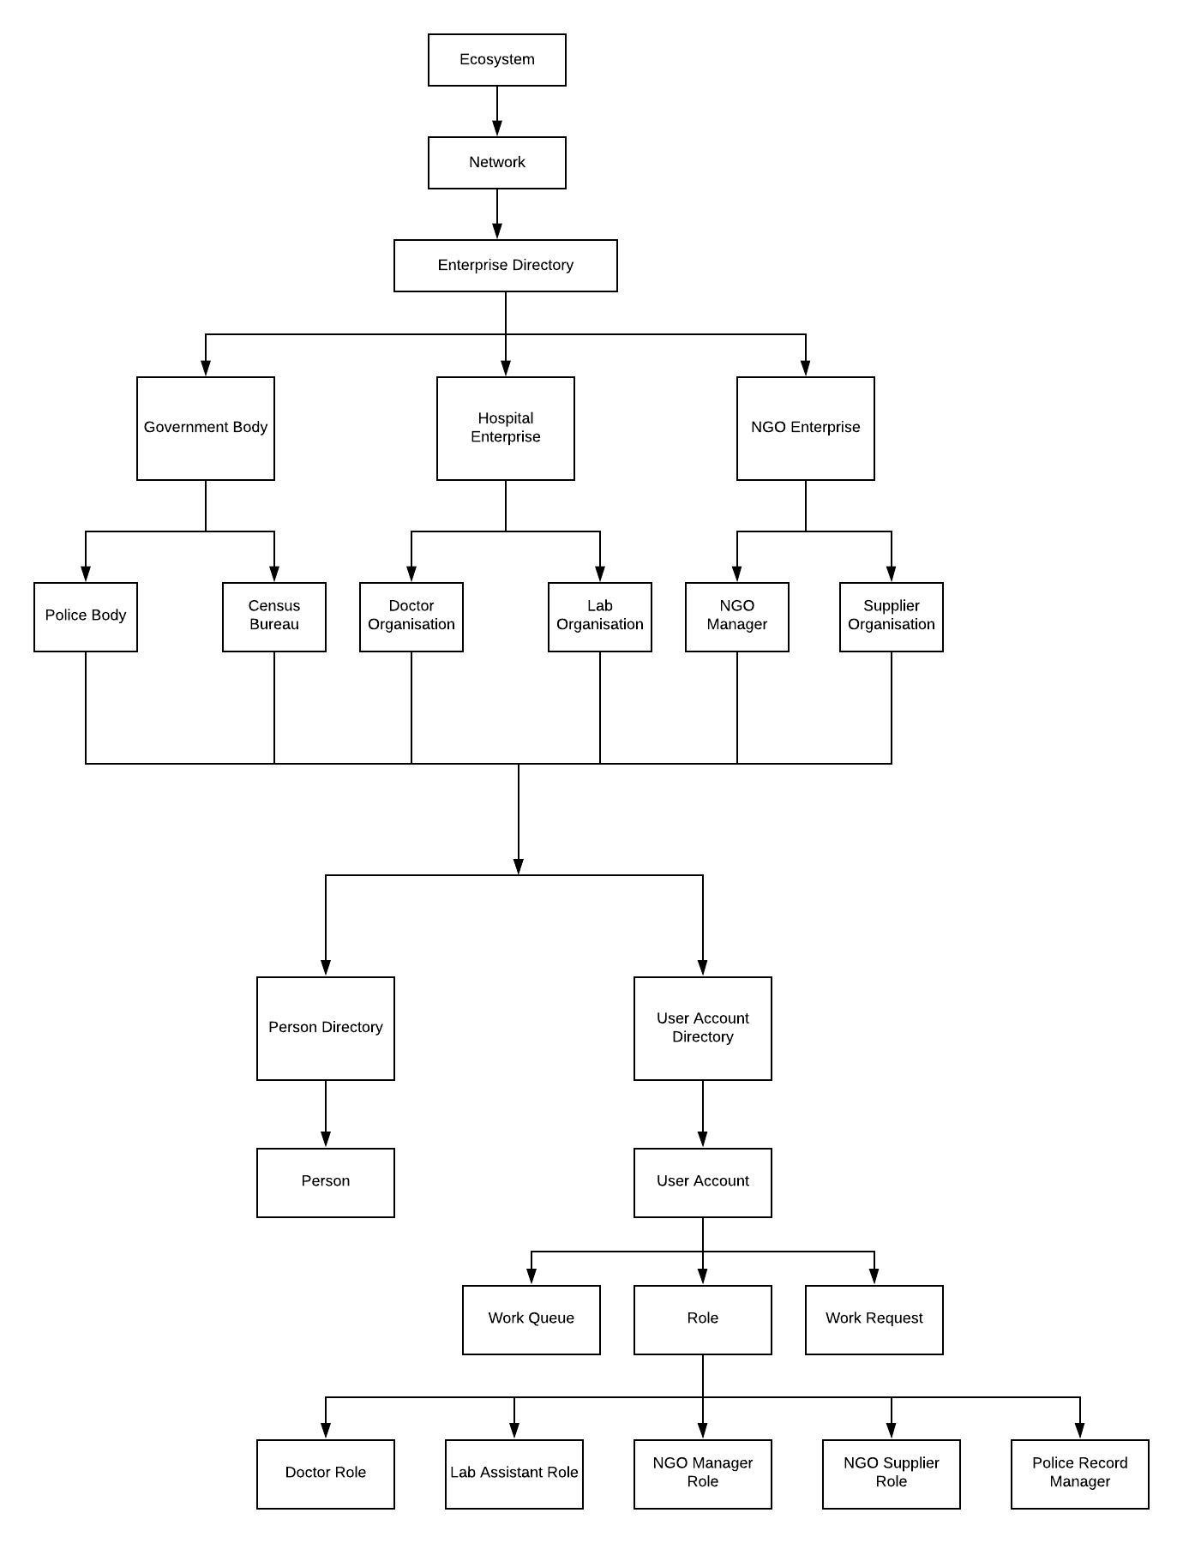

Proposed Entities

1. Homeless Person

* Name
* Age
* Gender
* Location
* Medical History
* Directory of Treatment Plan

1. Poverty Line

* Directory of Homeless Person
* Average Income
* Poverty Status

1. Criminal Record

* Directory of Homeless Person
* Past Criminal Instances
* Criminal Status

1. User Details

* Name
* ID
* Password
* Organization Role

1. Supplies

* Type of Supply
* Quantity

1. Shelter

* Location
* Vacancy
* Quarter
* Directory of Homeless Person

1. NGO Manager

* Directory of Homeless Person
* Directory of Supplies

1. Police

* Directory of Homeless Person
* Directory of Criminal Record

1. Census Bureau

* Directory of Homeless Person
* Directory of Poverty Line

1. Doctor

* User Directory
* Directory of Homeless Person

h. Lab Recorder

- Directory of homeless person

- Doctor

Organizational Flow Diagram

